**DILUTION SOLUTION!!** Name: _______________________

**Life Science Lab**  Date:_____________ Per:____

A ten-fold dilution reduces the concentration of a solution to one-tenth the original concentration. Done repeatedly, one can make ten-fold serial dilutions. These are useful for getting countable numbers of concentrated items, like bacteria or viruses in solution.

Today we will practice ten-fold serial dilutions using food coloring. We carry the dilutions out in small sterile test tubes (15 mL falcon tubes). These tubes have screw top lids to minimize the risk of contamination during the dilution.

Starting with a solution of food coloring in water we’re going to practice our pipetting. Let every member of the lab group do at least one of the dilutions.

**A ten-fold dilution**

|  |  |
| --- | --- |
| Step 1. | Use a 25mL pipet to dispense 9 mL of the diluent into each of five falcon tubes. |
| Step 2. | Add 1mL (~18 drops) of food coloring to the first tube, bringing total volume up to 10mL |

**A second ten-fold dilution**

|  |  |
| --- | --- |
| Step 3. | Use a 1mL pipetman to transfer 1mL (1000 uL) of the test solution to the new tube. Be careful not to suck up the liquid too quickly and be gentle with the pipetmen. Screw the top of the tube on. Discard pipet tip. |
| Step 4. | Mix by shaking by hand. |
| Step 5. | The tube now contains 1 mL of the first ten-fold diluted solution diluted by a further one tenth in a total volume of 10 mL. This is 100-fold diluted (1/100th) of the original concentration of the first solution. |

Repeat Steps 3-5 three more times until all five of your tubes are in the ten-fold dilution series.

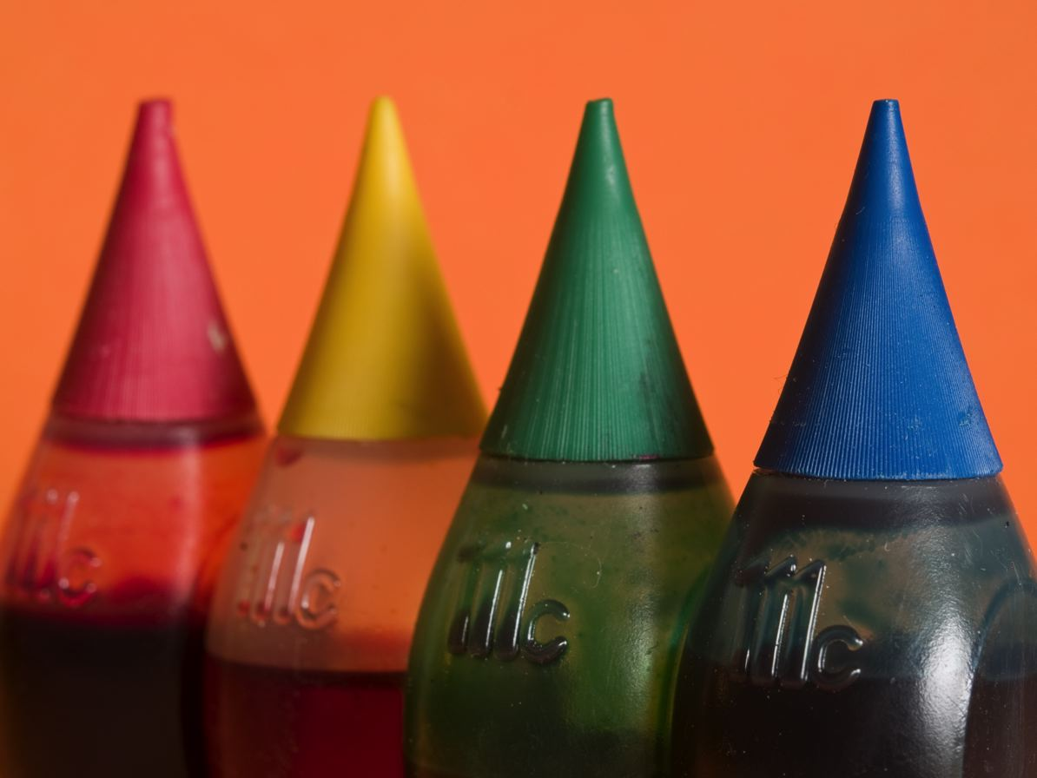

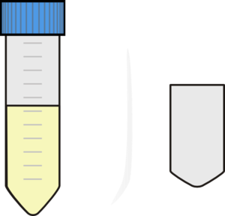

What fraction of the ______ ______ ______ ______ ______

original solution is

in each tube?

(write on the lines, NOT in the boxes)

These are all multiples of 10. Scientists use exponents instead of fractions to describe these ten-fold dilutions because exponents require writing many fewer numbers!

1/10 = 1/ ten to the first power = 1/101

1/100 = 1/ten to the second power = 1/102

There is still a simpler way to describe these values! Since the powers of ten are in the denominator of the fraction, we can signal that with a negative exponent.

1/10 = 1/ ten to the first power = 1/101 = 10-1

1/100 = 1/ten to the second power = 1/102 = 10-2

…or to make things easy and clear “-1” and “-2” for labeling those tubes.

Go back to the figure and label each empty box below each tube with the appropriate negative exponent.